**NEURAL NETWORK DEEP LEARNING ICP 5**

**700742210**

**VAMSHI KRISHNA RAPOLU**

# GitHub:

Repository URL for the source code : https://github.com/vxr22100/NNPL/tree/main/ICP5

# Zoom Recording:

https://github.com/vxr22100/NNPL/blob/main/ICP5/ICP5%20Video.mp4

**Question 1**

Implement Naïve Bayes method using scikit-learn library Use dataset available with name glass

Use train_test_split to create training and testing part

Evaluate the model on test part using score and classification_report(y_true, y_pred)

# Program & Explanation:

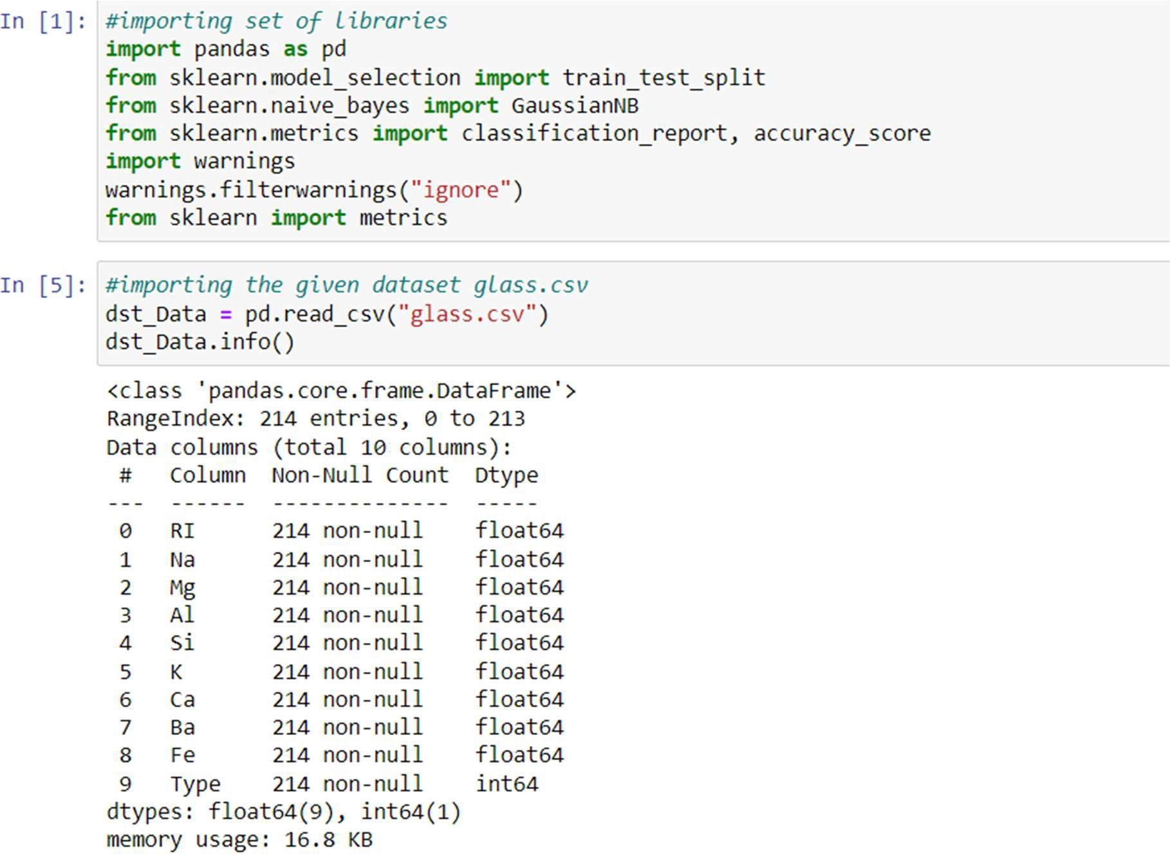

* Importing the set of libraries and csv file and printing information about glass csv datafame which includes index, columns, non-null values and memory usage.

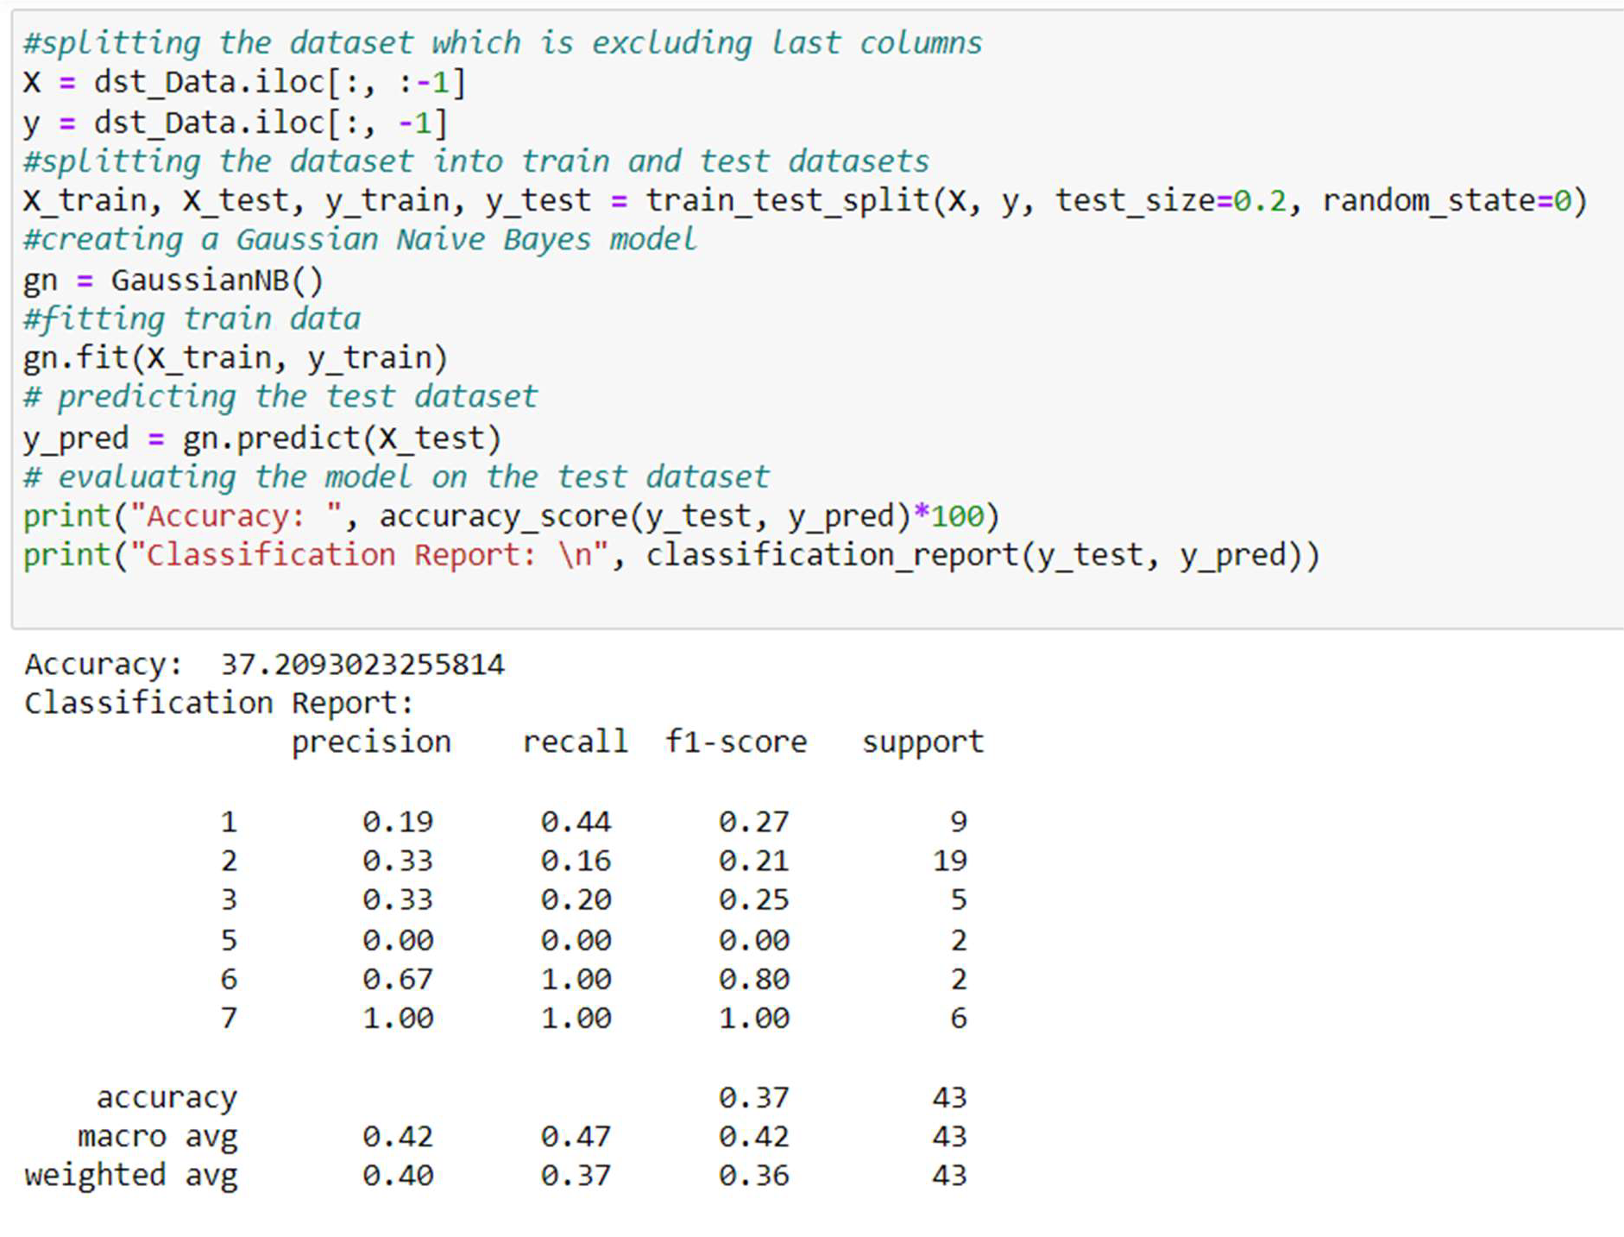

* Splitting the dataset using iloc function into features(x) and target variable(y). Then the data is split into training and testing sets using the ‘train_test_split’ function.
* Creating a Gaussian Naïve Bayes classifier using the ‘GaussianNB’ class.
* ‘fit’ method is used to train the classifier and ‘predict’ method is used to make predictions on test data.
* Finally evaluating and printing the accuracy and classification report.

**Question 2**

Implement linear SVM method using scikit library Use the same dataset above

Use train_test_split to create training and testing part

Evaluate the model on test part using score and classification_report(y_true, y_pred)

# Program & Explanation:

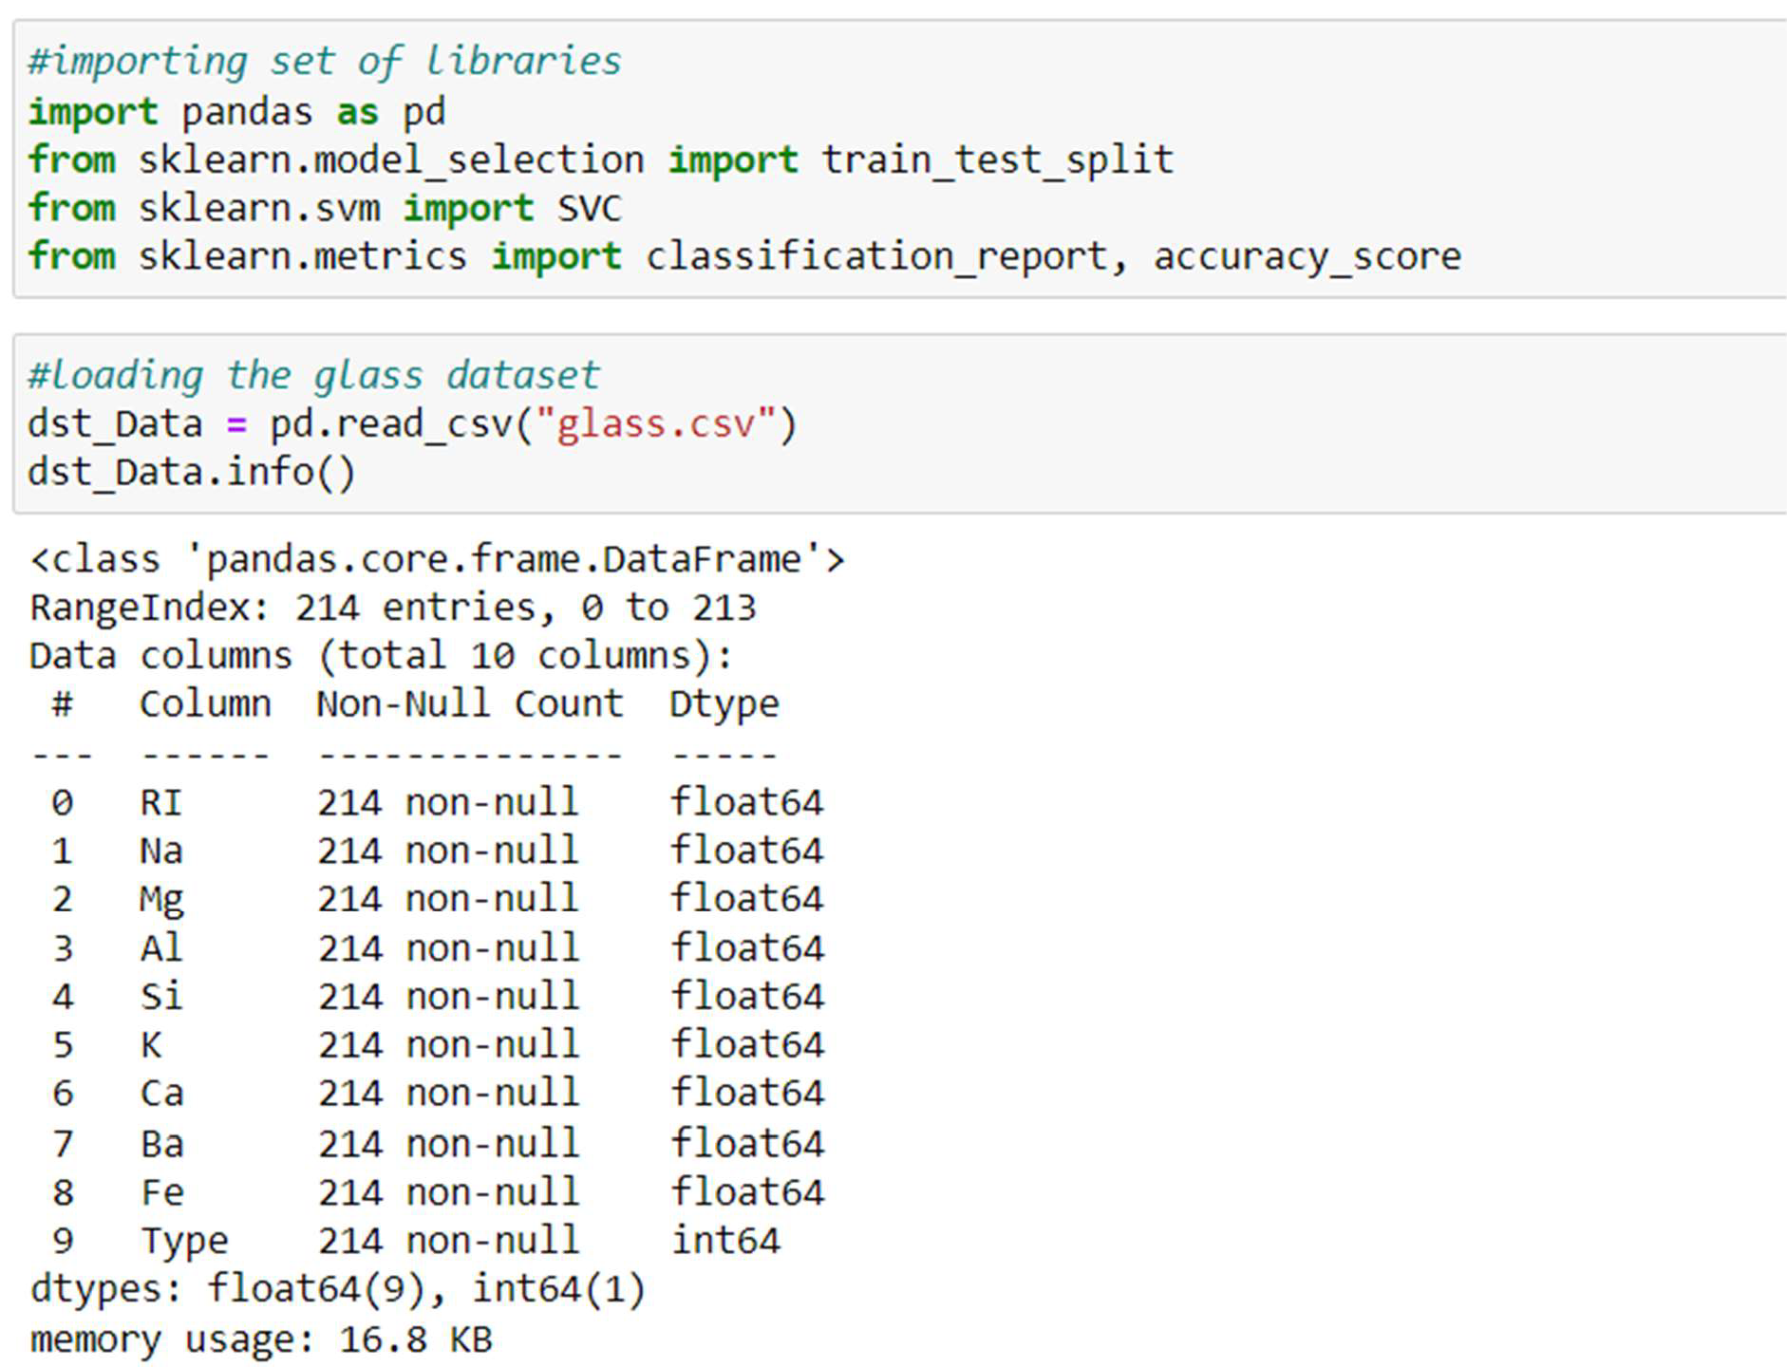

* Importing the set of libraries and csv file and printing information about glass csv datafame which includes index, columns, non-null values and memory usage.

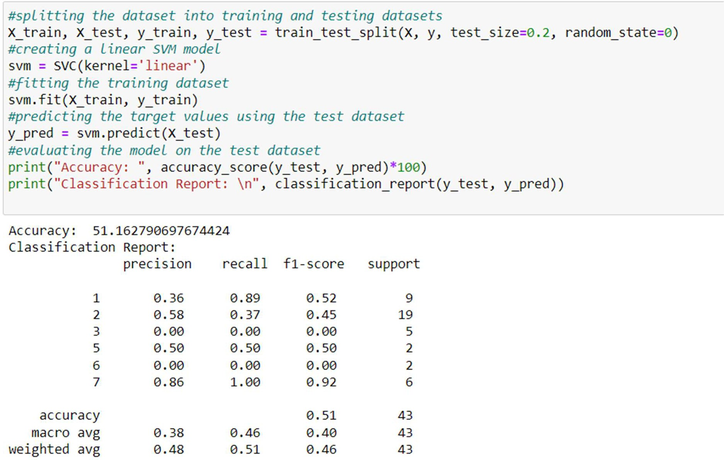

* The data is split into training and testing sets using **‘train_test_split’** function.
* Linear SVM classifier is created using ‘svc’ class with parameter ‘kernel’ set to ‘linear’.
* ‘fit’ method is used to train classifier and ‘predict’ method is used to predict data.
* Finally evaluating and printing the accuracy and classification report.

The accuracy of GaussianNB is 37.2, whereas the accuracy of Linear SVM is 51.16, which makes the SVM algorithm an accurate algorithm. As our datasets are linearly separable, we can use Linear SVM. When the datasets are not linearly separable, we can use NB, etc. As our dataset is linear, we got more accuracy for Linear SVM Algorithm compared to Naive Bayes Algorithm.